Miaolin Foods B2B AI Smart Distribution Platform Proposal
Submitted By: CRAVEVA PTE LTD Submitted To: Miaolin Foods Date: December 2025 Version: v5.0 (Omni-channel Integration & AI-Enabled Version)

1. Executive Summary
This proposal aims to build an "Omni-channel B2B Brand Distribution Management Center" for Miaolin Foods. Given Miaolin's role as a major importer managing multiple international agency brands and serving various tiers of B2B clients (chains, distributors, independent stores), we propose a solution based on Craveva AI Enterprise.
The plan adopts a pragmatic "Phased Digitalization" strategy:
- Phase 1 (Immediate Launch): Establish a standardized "Daily File-Based Integration" mechanism. Without altering the existing Digiwin (鼎新) ERP and Salesforce architecture, we will achieve immediate order automation and complex pricing management through smart import/export and automatic SKU conversion technology.
- Phase 2 (Future Planning): Upgrade to real-time API integration once platform operational data stabilizes.

2. Key Challenges & Requirements Analysis
Based on your business scenarios and current operations, we have identified five core challenges:
- Daily Maintenance of Complex B2B Pricing: Need to manage multi-brand and 5-level pricing logic (from public prices to client-specific contract prices). Due to raw material price fluctuations, the latest pricing strategies from the ERP must be synchronized to the platform every morning to avoid quotation discrepancies.
- Order Data Format Conversion (SKU Mapping): Clients place orders in "Units/Bottles", but Digiwin ERP requires entry in "Cartons". If exported order reports are not converted, subsequent manual modification is time-consuming and error-prone.
- Unified Multi-Brand Management: As an importer, you need to manage all agency brands in a single backend, allowing clients to make one-stop purchases while facilitating headquarters to consolidate orders efficiently.
- Manual Overload & Fragmented Order Sources: Current orders come from Website, Line groups, and other channels in varying formats (text, screenshots, voice). Sales assistants spend excessive time manually organizing, confirming specifications, and keying in orders, leading to low efficiency and missed orders.
- Data Silos & Difficult Analysis: Sales data is scattered across Digiwin ERP, Salesforce, Google Workspace, and Line chat logs, lacking a unified "Data Middle Platform" to integrate these heterogeneous data sources, making it difficult for management to grasp the real-time sales picture across brands.

2.1 Current Manual Process Flow vs Proposed Automated Workflow

BEFORE
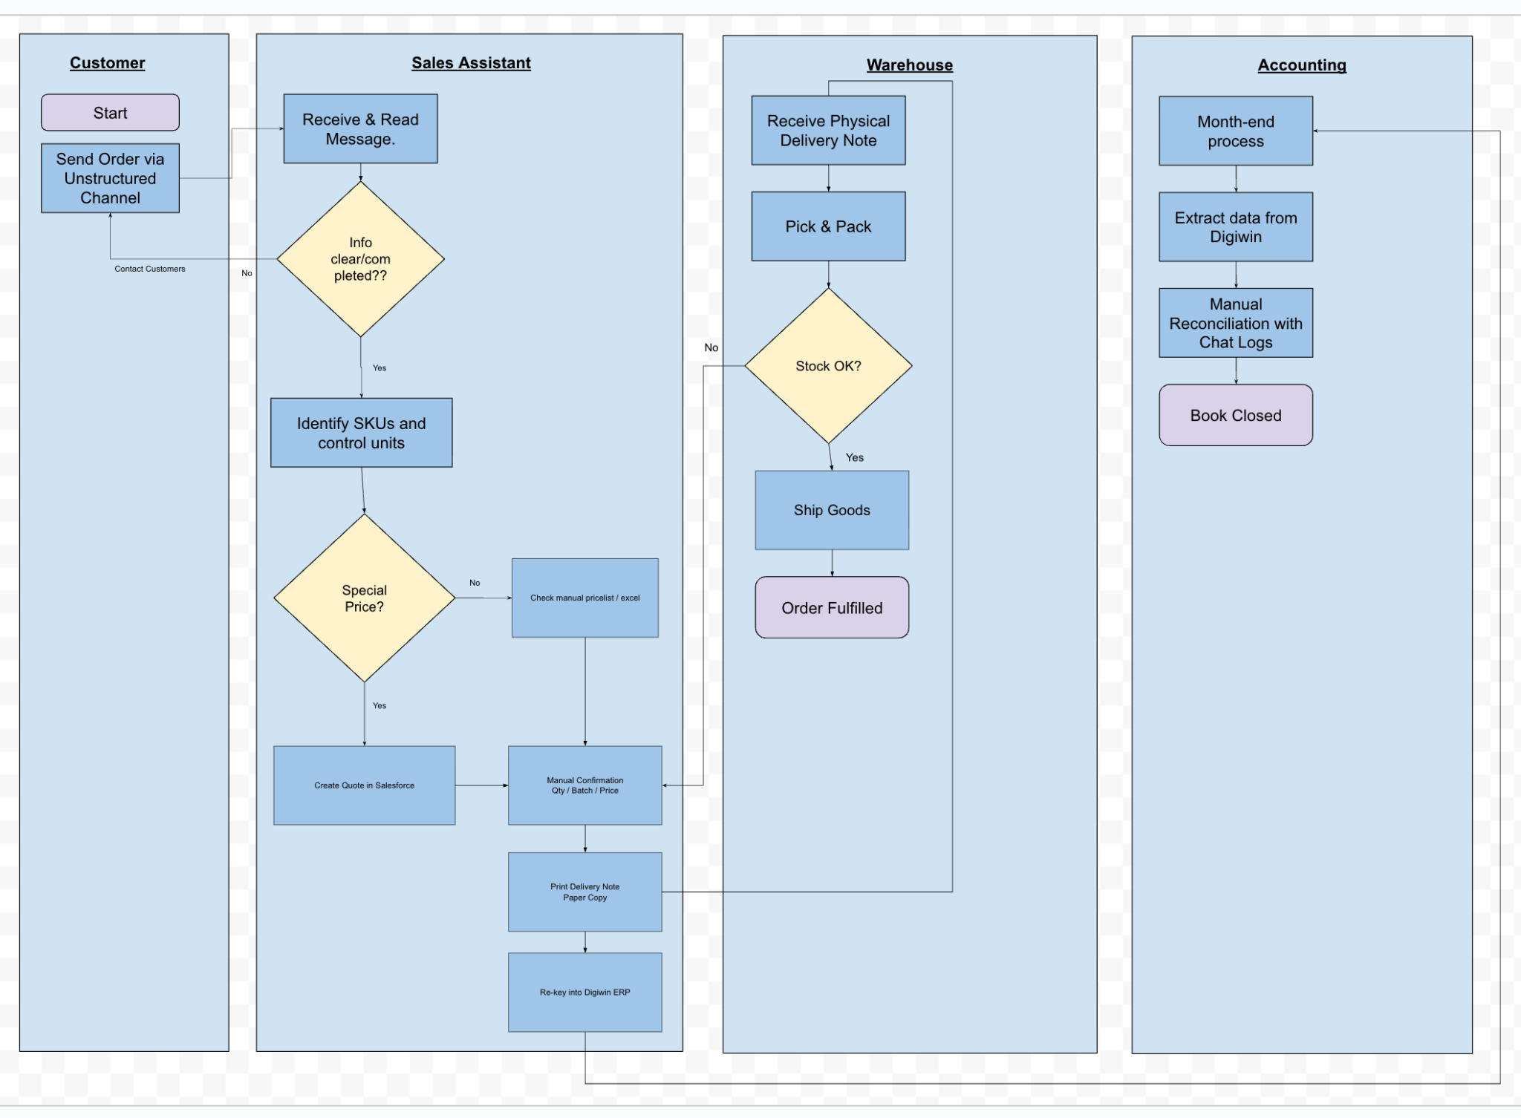
After
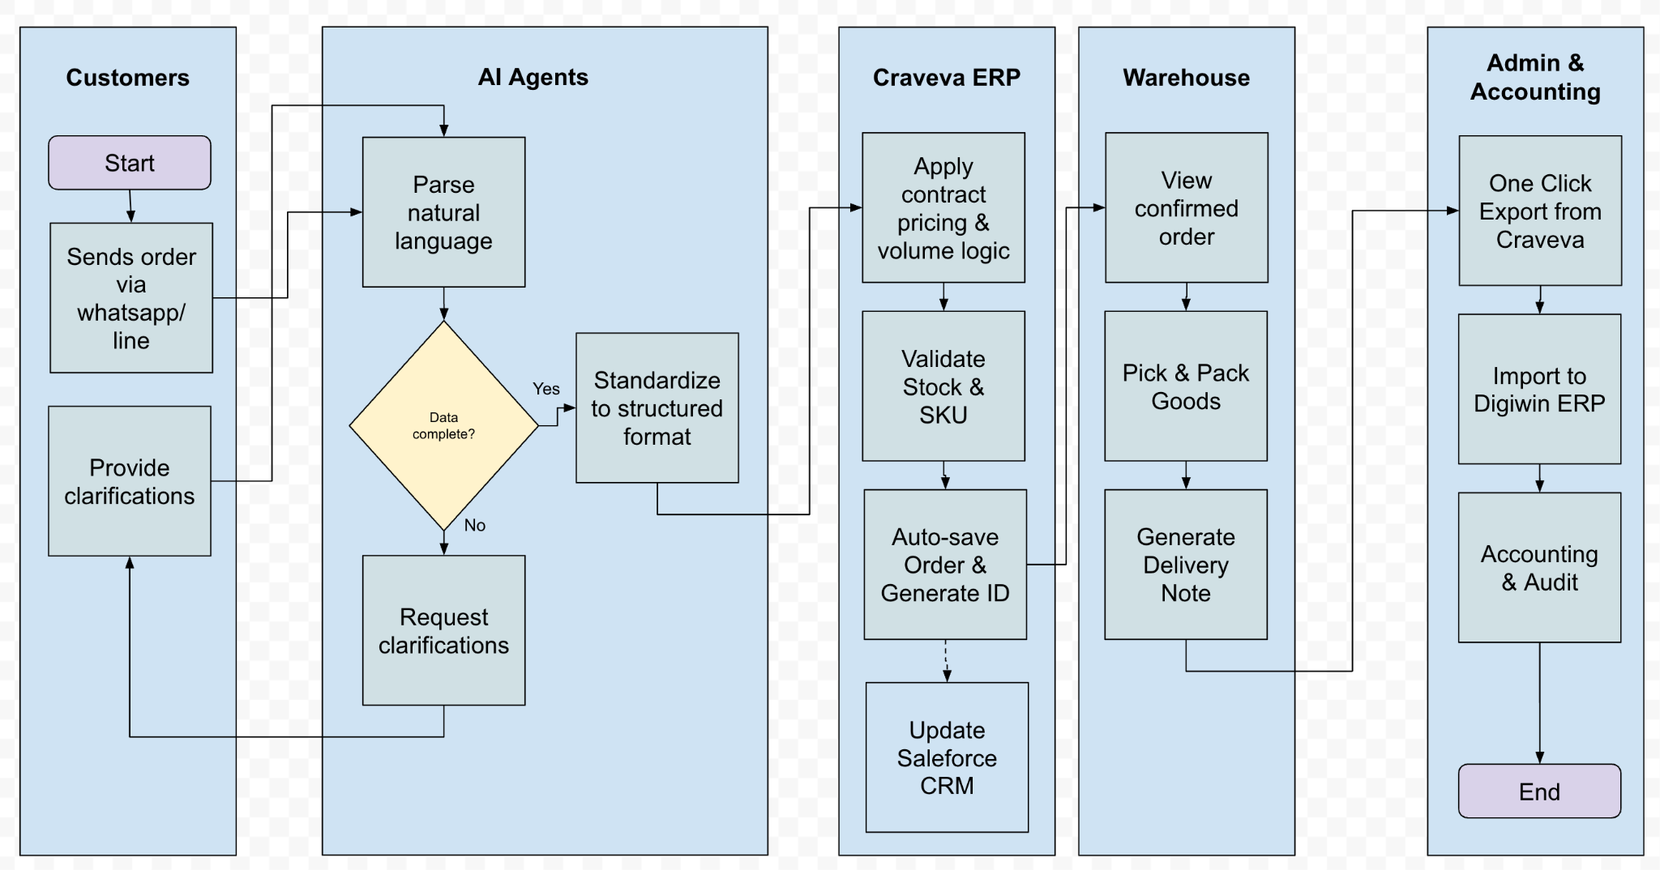
- Eliminates manual order handling and pricing errors
- Enables real-time inventory, pricing, and credit control
- Provides management with live operational intelligence

3. Solution Architecture
This solution uses Craveva AI Enterprise as the core foundation, building Miaolin Foods' digital distribution hub through a modular stack. The architecture is divided into three layers: Core Operations, Intelligent Pricing, and AI Enablement.

3.1 Core Modules Configuration
To address the multi-brand management needs of an importer:
- Supply Chain & Procurement:
  - Multi-Brand Inventory Center: Supports HQ in centrally managing master data and inventory for multiple agency brands (e.g., Japanese flour, French butter), including batch and expiration date management.
  - Virtual SKU Mapper: Responsible for automatically converting the "Sales Unit (Unit)" from frontend orders into the "Inventory Unit (Carton)" recognized by the ERP for seamless data transfer.
- Financial Management:
  - B2B Accounting Integration: Handles invoices, Credit Notes (rebates), and tax calculations, ensuring exported financial data formats are compatible with Digiwin ERP.
- Customer & Partner Management:
  - B2B Customer Portal: Provides a tiered account system, allowing different levels of clients (Chain HQ vs. Franchisee) to have corresponding purchasing permissions and price visibility.
- Insights & Governance:
  - Data Middle Platform: Aggregates heterogeneous data from ERP, Line, and Web, providing Role-Based Access Control (RBAC) and a visual war room (dashboard).

3.2 Intelligent Pricing Engine
To solve Miaolin's extremely complex quotation system, the system has a built-in 5-Level Priority Override Logic, ensuring pricing precision and contract compliance:
- Level 1: Base Price - System underlying MSRP.
- Level 2: Public Price - [Overrides Level 1]. Displayed to non-logged-in visitors (usually higher to protect the dealer network). (Note: Do not disclose to non-logged-in visitors).
- Level 3: Tier Pricing - [Overrides Level 2]. General discounts set for specific customer groups (e.g., Platinum Distributors, Catering Channels) (e.g., 10% off storewide).
- Level 4: Client-Specific Contract Price [★ Highest Priority] - [Overrides all lower levels]. Daily Sync Mechanism: Supports daily Excel import from ERP. Locks absolute prices for "Specific Client (Client A) + Specific Product (SKU 001)" to ensure consistency with offline contracts.
- Level 5: Volume Discount - [Final Adjustment]. Based on the above prices, if the purchase quantity reaches a threshold (e.g., 10 bags/1 carton), an additional rebate or carton price is automatically triggered.
  - (Note: No need for cumulative quantity within a specific period).
- Logic for Carton Pricing with Different Batches: Test Digiwin system acceptance (currently manual selection in orders).
- Short-Expiry Goods Pricing: Controlled by Batch Number and Expiry Date. Different prices are set based on logic (%) and price upon entry.
(Image Note: Assessment >> Phase 1: Only use standard price and client price via Line >> Phase 2: Apply special promotions. Export/Import product data needs text only, no images.)

3.3 AI Capabilities
Introducing Craveva's proprietary AI Agent technology to upgrade the passive order-taking system into an active intelligent business assistant:
- AI Procurement Assistant
  - Scenario: Solves efficiency bottlenecks in Line and text message ordering.
  - Function:
    - Natural Language Ordering: When a client sends "I want the same flour as last week, plus two cartons of butter" on Line, the AI automatically parses the intent, compares it with history, and generates a standardized cart link for confirmation.
    - Error Prevention: If the instruction is vague (e.g., just "flour" but there are three specs), the AI automatically asks for clarification.
    - (Note: Needs to determine if there is inventory, but does not need to tell the customer the actual quantity).
  - AI Order Recognition & Error Prevention Mechanism

Ambiguous Product Name Handling (Mandatory Confirmation): When a customer submits a non-specific product name (e.g. “Butter”), the AI will not auto-confirm the order. Instead, the AI dynamically generates clarification options based on Miaolin’s product master data.
Example:
Customer message:
- “I want 2 cartons of butter.”
AI response:
- “Please confirm which product you mean:
1️⃣ Brand X Butter (SKU: BX-001)
2️⃣ Brand Y Butter (SKU: BY-002)
3️⃣ Brand Z Butter (SKU: BZ-003)”
The order proceeds only after explicit customer confirmation.

Client-Specific Order History Matching: The AI compares the current request against the historical purchase patterns of the same client.
Logic:
- If Client A has repeatedly ordered “Brand Y Butter” in past orders
- And now sends “same butter as usual” or simply “butter”
- The AI will propose the most likely match first, while still requiring confirmation
Example AI clarification:
- “You usually order Brand Y Butter (SKU: BY-002).
Please confirm if this is correct or choose another option.”
This significantly reduces mis-ordering while respecting customer habits.

- AI Sales Agent
  - Scenario: 24/7 Product consultation and business development.
  - Function:
    - Product Knowledge Base: Learns specifications (PDFs) of all Miaolin agency brands. If a client asks, "What is the fat content of this cream?" or "Where is the origin?", the AI answers accurately in real-time.
    - Related Recommendations: Proactively recommends suitable pairing items based on browsing history.
- AI Data Analysis (Internal Use)
  - Scenario: Cross-channel, cross-brand operational insights.
  - Function:
    - Omni-channel Integration: Cross-analyzes shipment data from ERP, integrable channels, and Line/Web order data.
    - Proactive Insights: Generates weekly reports flagging anomalies. E.g., "Brand A inventory turnover dropped 15% this week, suggest promotion" or "Client B hasn't ordered for two weeks (Churn Warning)."

3.4 Headless Commerce Integration
To meet Miaolin's high customization needs for brand image, this solution supports "Headless Commerce" architecture. Craveva acts as the robust backend digital engine, seamlessly connecting with the frontend website developed by your designated design team via standardized APIs.
A. System Boundaries
- Frontend Layer (External Design Team): Responsible for UI/UX, visual presentation, RWD, and creating a unique shopping flow.
- Backend Logic Layer (Craveva):
  - Product & Inventory Hub: Provides product info, specs, and real-time inventory.
  - Smart Pricing Calculation: When the frontend queries price, Craveva returns the precise contract price based on the "5-Level Logic," ensuring the frontend doesn't need to rewrite complex formulas.
  - AI Core: Provides API interfaces for AI conversation and recommendation engines.
B. API Integration Flow We will provide full Storefront API documentation covering:
- Catalog API: Frontend retrieves product list, images, specs, and sellable inventory.
- Pricing API: When a B2B client logs in, the frontend sends Client_ID & Product_ID; Craveva returns the calculated Final_Price (including Level 4 contract price).
- Order API: After checkout, order data is written to Craveva, triggering the "Virtual SKU Mapping" and "ERP Export" processes.
- AI Widget: Embeds the AI Sales Agent as a "Chat Widget" or via API for 24/7 service.

3.5 Risk Mitigation & Service Levels
To ensure operational continuity and limit liability:

- Duplicate Orders: System detects duplicates and flags for review.
- Invalid SKUs / Batch Errors: Orders with invalid or missing data will be rejected with alert to Admin.
- Rollback Capability: Daily import and pricing updates are version-controlled and revertible.
- SLA / Uptime: Craveva guarantees 99.9% system uptime. Critical issues will be responded to within 2 hours, and resolved within 24 hours.
- Audit & Logs: All automated and manual overrides are logged for traceability.

4. Daily Operational Workflow
To align with the "Daily File Exchange" model:
- Morning Sync (08:30 AM):
  - Admin exports Inventory Table and Client Price Table from Digiwin ERP.
  - Upload to Craveva; system automatically updates site-wide sellable inventory and Level 4 specific prices.
- Trading Hours:
  - Line/Text: AI Procurement Assistant handles text orders automatically.
  - Web Portal: Clients log in to order and see their exclusive prices in real-time.
- Evening Export (Latest by 11:00 AM next day - TBC):
  - Admin one-click downloads the Daily Order Summary.
  - Key Action: System executes "Virtual SKU Mapping" to convert "Units" in orders to "Box SKUs" required by ERP.
  - Import file into Digiwin ERP to complete daily accounting.
  - (Note: Handling mode for duplicate order imports needs to be defined).

4.1 Order Status & Inventory Alignment Sync (Digiwin → Craveva)
To ensure accurate order tracking and real-time customer communication, Miaolin will periodically export the Order Status List from Digiwin ERP to the Craveva Platform.
Process Flow:
- Order Status Export from Digiwin ERP
  - Miaolin exports an Order Status File containing:
    - Order ID
    - Fulfillment status (e.g. Confirmed / Picking / Delivered / Cancelled)
    - Delivery date & time (if available)
  - Export frequency: configurable (e.g. hourly / end-of-day).
- Import into Craveva Platform
  - Admin uploads the Order Status File to Craveva.
  - Craveva maps Digiwin Order IDs to Craveva Order Records.
- System Updates & Alignment
  - Order status is updated in Craveva in near real-time.
  - AI Procurement Assistant can:
    - Instantly answer customer order status inquiries.
    - Prevent duplicate or conflicting orders.
  - Inventory levels are reconciled against:
    - Confirmed orders
    - Fulfilled quantities
    - Cancelled or adjusted orders
- Single Source of Truth
  - Digiwin remains the system of record for fulfillment.
  - Craveva becomes the customer-facing visibility layer, ensuring consistency across sales, inventory, and support.
Phase 2 (Optional): API-Based Status Sync
- Order status and inventory updates flow automatically from Digiwin to Craveva without manual file uploads.
- Enables near real-time customer notifications and exception handling.
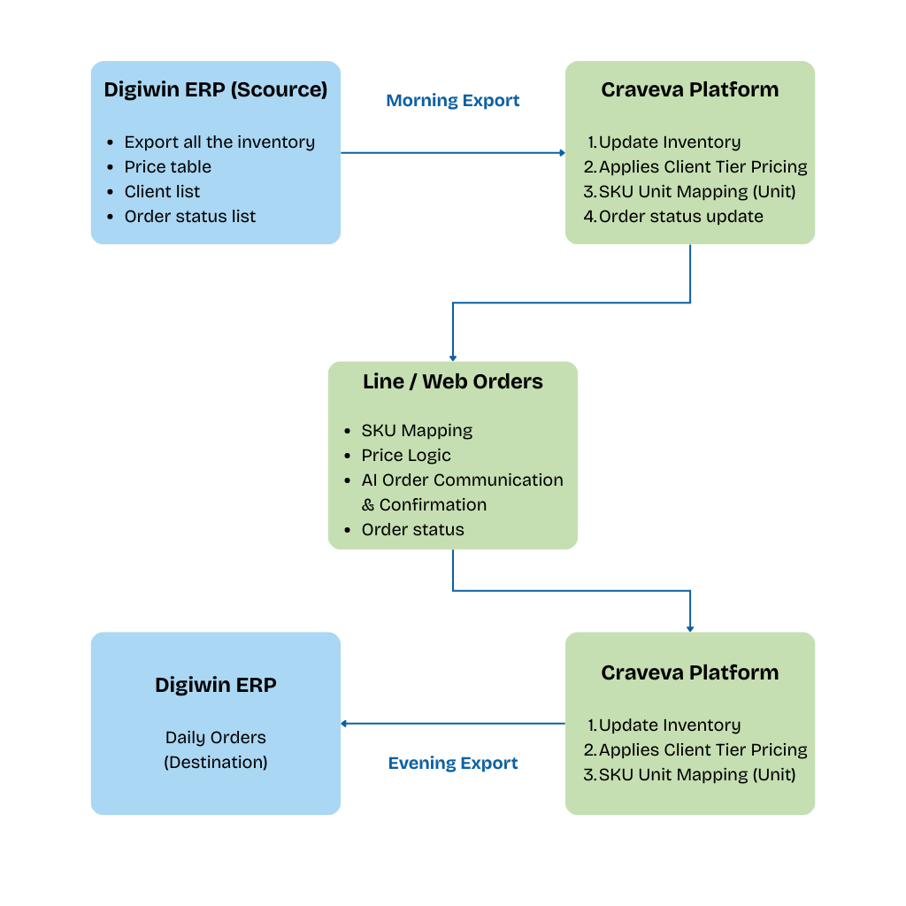

5. Implementation Roadmap
Estimated 12-14 Weeks for Phase 1 Go-Live (excluding frontend design time):
- Phase 1: Infrastructure & Data Cleansing (Weeks 1-4)
  - Build multi-brand product database.
  - Key Task: Define Digiwin ERP Import Template (Excel) and SKU conversion rules.
- Phase 2: AI Training & Pricing Configuration (Weeks 5-8)
  - Train AI to recognize Line order slang (e.g., "add on", "the usual").
  - Configure 5-level pricing logic and test daily import flow.
- Phase 3: Omni-channel Process Drill (Weeks 9-11)
  - Simulate the full loop: "ERP Export -> Craveva Order Taking (Line/Web) -> Transcoding -> ERP Import" to ensure zero data errors.
- Phase 4: UAT & Official Launch (Weeks 12-14)
  - Official switch-over, staff training, and AI Assistant launch.

6. Investment Proposal
We recommend the Craveva Enterprise Plan:
A. Project Implementation Fee (One-time)
- Digiwin ERP Format Converter (SKU Mapping Module) development.
- Line Order AI Parsing Integration Module.
- Daily Pricing Import Automation Logic Configuration.
- Custom Frontend API Support:
  - Storefront API documentation.
  - Technical alignment meetings with the design team.
  - API integration testing support (Sandbox).
- Professional Onsite Service and data cleansing assistance.
B. System Subscription Fee (Recurring - Annual/Monthly)
- Unlimited Expansion: Unlimited Users, Access to All Modules.
- Includes full Craveva platform rights (ERP, CRM, HR, Project Management, and future modules).
- Cloud hosting, maintenance, 99.9% uptime, and security backups.
- Future Major Upgrades: Free access to all feature updates and security patches.
C. AI Usage Fee (Pay-per-Token)
- Model: Pay-per-Token.
- Description: For high-volume AI computing (Line parsing, large-scale data analysis, sales Q&A).
- Advantage: Precise cost control, paying only for actual value generated.

7. Conclusion & Next Steps
This solution liberates Miaolin Foods from tedious manual order taking and pricing maintenance.
Suggested Next Steps:
7.1 Administrative & Commercial
- [v] Sign NDA: Priority before accessing ERP data/client lists.
- [ ] Confirm Requirements & Contract: Confirm the scope in the "Investment Proposal" and sign the contract.
7.2 Technical Preparation
- [ ] Provide Digiwin ERP Standard Import Template (Excel/CSV): (TBC)
  - For developing the "Virtual SKU Mapper." Must mark mandatory fields (Client Code, Inventory No., Warehouse Code).
- [v] Provide Existing Product Master & Inventory Template:
  - For testing "Morning Sync." Includes Name, SKU Code (Unit/Box), Batch format.
- [ ] AI Training Corpus Collection:
  - Line Chat Logs: Provide ~50-100 anonymized "Real Client Order Messages" (screenshots/text) for training AI. (Query: Can we use Line API to crawl history?)
  - Product Knowledge Base: Specs/PDFs for AI Sales Agent training.
7.3 Project Coordination
- [ ] Tri-party Tech Kick-off:
  - Attendees: Miaolin Lead + Website Designer (Zhengzhi) + Craveva Architect.
  - Agenda: Hand over Storefront API docs, confirm data flow, define debugging responsibilities.
- [ ] SKU Mapping Workshop:
  - Attendees: Miaolin Admin/Procurement Lead + Craveva Data Engineer.
  - Content: Review major brands to confirm "Unit-to-Carton" rules (e.g., Flour A = 10 bags/box).

